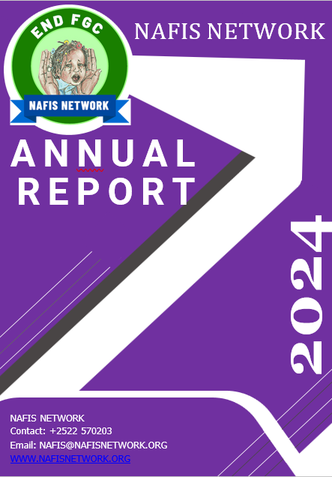
NAFIS Network
2024

A Year of Advancement, Creativity, and Impact

This Annual Report chronicles the combined accomplishments of our committed teams, regional partners, and empowered communities throughout
Somaliland. It symbolizes our common path in 2024. 1

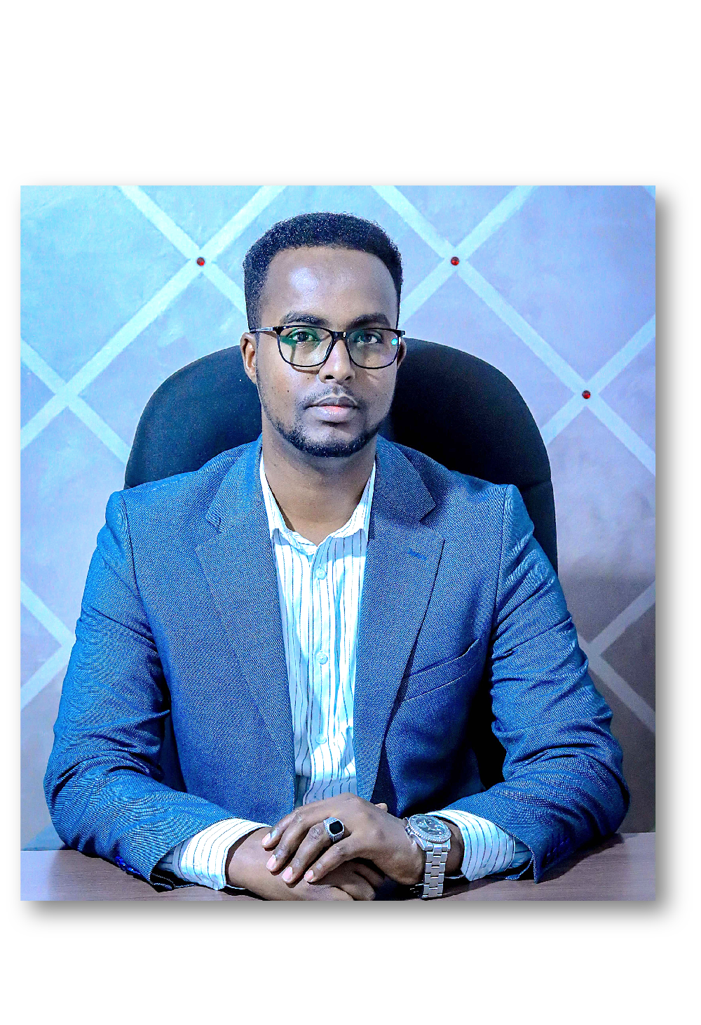
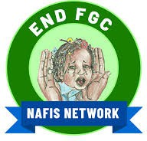

Message from the Executive
2
Director

Dear Partners, Stakeholders, and the Communities We Proudly Serve,

It is with great pride and gratitude that I present the NAFIS Network 2024 Annual Report a reflection of a transformative year marked by resilience, collaboration, and meaningful impact across Somaliland. Throughout 2024, we advanced our mission to promote gender justice, social protection, and inclusive development in the face of complex social, economic, and environmental challenges.
Our collective efforts led to several key achievements, including the national endorsement of the Anti-FGM/C Policy, a major milestone in our fight to end harmful practices and protect the rights of women and girls.
We facilitated the formation of 212 new self-help groups through our promoted organizations, enabling women to access livelihoods and gain economic independence. Over 25,000 individuals, primarily survivors of gender- based violence and FGM, received essential health, psychosocial, and legal support through our integrated protection services.
Recognizing the power of collective voice, NAFIS convened national and regional coordination meetings to strengthen the role of civil society, unify advocacy efforts, and elevate grassroots concerns to decision-makers. We also expanded our climate adaptation and resilience work, equipping rural women and youth with tools to lead community-driven solutions. Capacity development remained central to our approach; over 16,000 people benefited from training in leadership, child protection, and FGM/C prevention, laying the groundwork for sustainable, community-led change.
These accomplishments would not have been possible without the tireless commitment of our team, the trust of the communities we serve, and the unwavering support of our partners and donors.
As we look to the future, NAFIS remains dedicated to building a just, inclusive, and resilient Somaliland, where every individual, especially women and girls, can live in safety, dignity, and opportunity. We invite all stakeholders to continue this journey with us as we strive for deeper impact and systemic change.
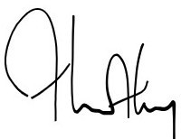
Warm regards, Muse Jama Essa Executive Director NAFIS Network

Our Geographical and Strategic Operations

NAFIS Network operates across multiple regions of Somaliland, with a focus on both urban and rural settings, targeting marginalized and vulnerable populations, particularly women, youth, and IDPs. The main areas of operation include:
Primary Regions

Maroodi-jeh region Togdheer region Sahil region Sanaag region Awdal region Sool region
Target Communities

Internally Displaced Persons (IDPs)
Host communities Women-led Self-Help Groups





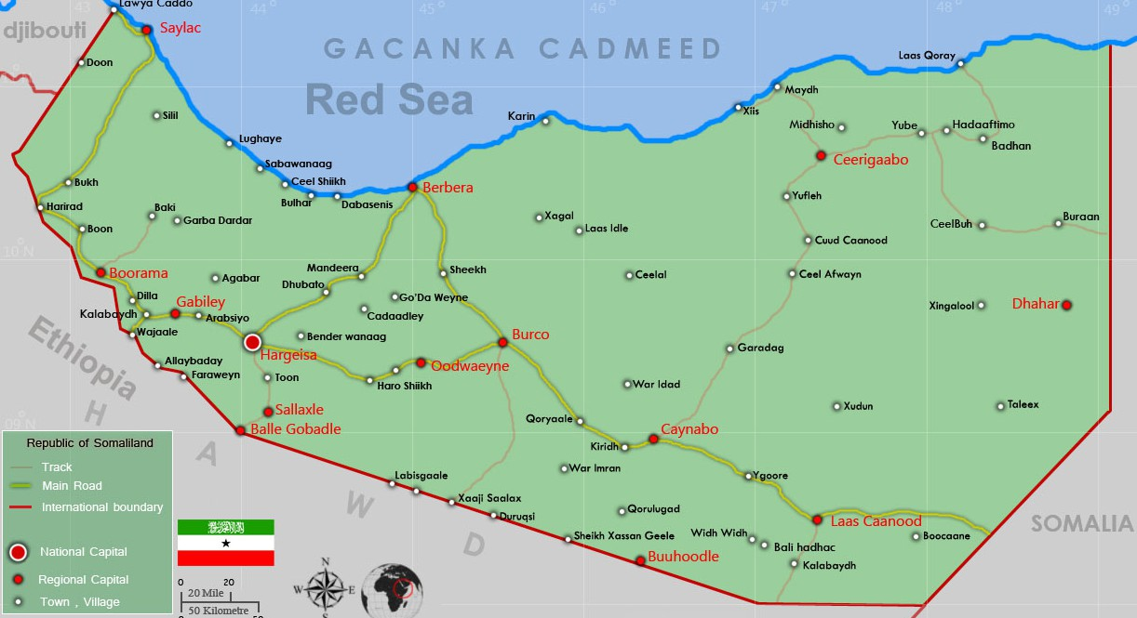
Youth groups and local civil society organizations (CSOs)
Traditional leaders and community-based structures
3



Community engagement
Policy advocacy
Economy empowerment

In 2024, NAFIS directly engaged over 16,000 community members, including women, youth, and leaders, empowering them through leadership, advocacy, and health trainings, especially in hard-to-reach eastern regions.
NAFIS influenced the landmark approval of the FGM/C policy at the ministerial level, ensuring civil society voices shaped key legislation and expanded access to justice for vulnerable groups through local forums and survivor support.
Our women-led economic programs flourished, establishing 212 new Self-Help Groups across six regions. These groups amassed over
$287,000 in savings, fostering entrepreneurship and economic independence for thousands of women.

2024 NAFIS Network
Report

Health
Health and protection efforts raised awareness on gender-based violence, child marriage, and reproductive health, strengthening social norms and expanding comprehensive health services in underserved areas.


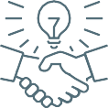
Legal empowerment power Climate Change Partnerships

Legal empowerment initiatives expanded community paralegal networks and survivor- centered services, promoting justice accessibility and reinforcing community-based support systems across Somaliland.
4
NAFIS launched climate resilience projects supporting over 100 women-led enterprises and community infrastructure, enhancing livelihoods while building institutional and financial capacity among grassroots organizations.
Our partnerships and outreach fortified regional cooperation through Cluster Level Associations, driving business development and resource mobilization despite regional disparities and environmental challenges.

In 2024, NAFIS Network advanced gender justice and community empowerment across Somaliland, fostering a future where women and girls live free from violence and discrimination.

NAFIS Network implements the largest women’s empowerment program in Somaliland to boost economic independence, social and political contributions through a self-help group.
In 2024, NAFIS scaled through promoted organization by SHG initiatives focusing on economic empowerment, savings mobilization, and entrepreneurship across Somaliland.

16,960

SHG members participated in trainings covering leadership, financial literacy, business skills, group governance, record keeping, savings and loan systems, decision-making, accountability, self-confidence, social empowerment, and SHG sustainability.

212 New SHGs





were established in
1.1. Economic Empowerment
- Sanaag (51)
- Maroodi-jeeh (48),
- Awdal (40),
- Togdheer (35),
- Sool (20),
. Sahil (18).

Business development included 5,306 expanded businesses (Maroodi-jeeh led with 2,814) and 16,246 new businesses (Maroodi-jeeh led with 7,890).

Total annual SHG savings reached $287,631
which had contributions from various regions: Sanaag led with
$100,310, followed by Awdal at $89,507. Togdheer and Maroodi- jeeh contributed $44,352 and $42,229, respectively, while Sahil and Sool added $8,576 and $2,657.


CLAs facilitated grassroots economic growth & established businesses in Awdal (7 CLAs, 13 businesses), Maroodi-jeeh (2 CLAs, 12 businesses),

Sanaag (5 CLAs, 6 businesses), Togdheer & Sahil (2 CLAs each, 3 businesses each), Sool (no new CLAs, 2 businesses).

1.2. Social Empowerment
2,000 women
Women trained on leadership, community rights, and advocacy against FGM/C and early marriage.
Following these efforts, local economies experienced sustained growth, entrepreneurship flourished, and savings mobilization increased significantly, although the impact varied notably across different regions.

10 female
Change agents trained to lead advocacy campaigns to influence attitudes against harmful practices subsequently organized community workshops, engaged with local leaders, and implemented educational programs, leading to increased awareness and a gradual shift in public perception.


600 women 230 individuals

Publicly committed to ending FGM/C and early/forced marriages.
(216 women, 8 youth, 6 persons with
disabilities) trained in leadership development to enhance participation in decision-making.

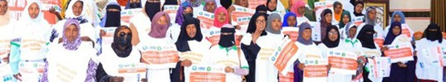

1. Women’s Empowerment
5

1.3. Women Political Empowerment

230 individuals
are trained to participate effectively in decision-making spaces.
There has been an increase in the representation and meaningful participation of individuals, particularly women and marginalized groups, in local governance and decision-making forums.
Advocacy consultations engaged 150 participants to promote women’s and girls’ inclusion through sports and arts, fostering awareness, dialogue, and community support for gender equality and creative expression as tools for empowerment.
High-level policy dialogues and advocacy
consultations strengthened political commitment to combat VAWG and FGM, resulting in improved legal reforms, policy enforcement, and resource allocation.

The program successfully trained female change agents and SHG members in advocacy skills. This training resulted in enhanced confidence among women and increased their capacity to influence policies and decisions, which led to greater participation and leadership roles in local and regional governance, improved representation of women's interests, and stronger community support for gender equality.

1.4. Climate Resilience and Women’s Empowerment

Women in SHGs gained diversified income sources and increased financial security, while communities strengthened their capacity to withstand climate shocks through improved structures and resources.

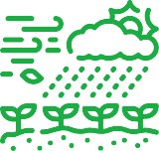
Over 100 small enterprises were established in Garbahaadlay, Caro- Malko, and Xidh-Xidh villages, boosting local economic growth and creating new employment opportunities that improved livelihoods in the targeted communities.
Portable solar panels were introduced to rural communities, increasing access to clean energy, enhancing renewable energy use, improving environmental sustainability, and strengthening resilience to climate change.

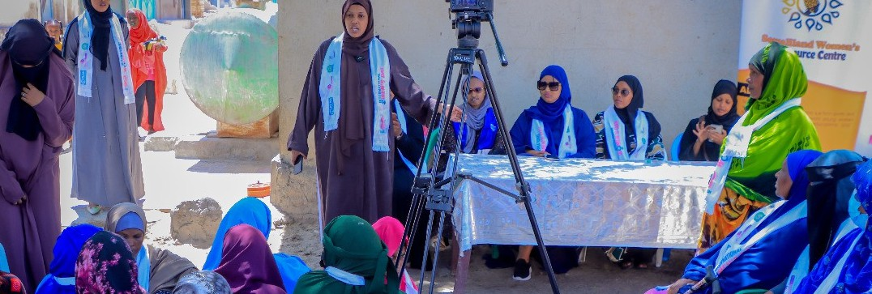
6

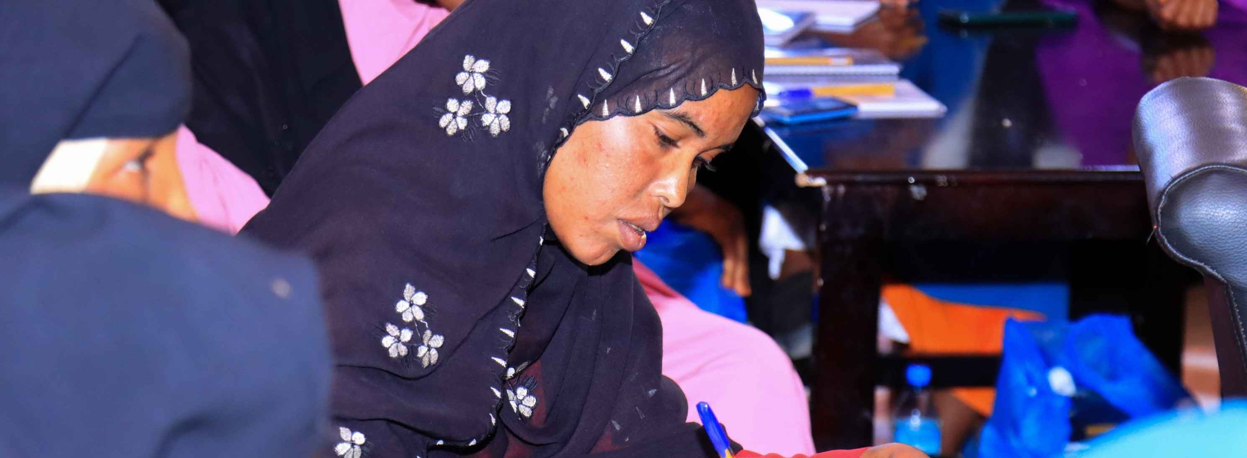

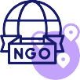
26 Women
underwent intensive advocacy training on women’s and girls’ participation and leadership. This resulted in increased women’s and girls’ representation and active participation in community leadership and decision- making processes, leading to greater gender equality, empowerment, and inclusive governance at the grassroots level.


Through NAFIS Support, WAAPO Safe Spaces organizationally supported providing shelter and counseling for GBV survivors.
15 CSOs
trained in advocacy, legal frameworks, mobilization, and survivor-centered VAWG approaches.
CSOs are better equipped to advocate for gender justice, support survivors(VAWG), engage communities, and influence policy using rights- based and survivor-centered approaches.

10 CSOs are equipped to lead peacebuilding and gender equality advocacy.

200 Women’s Rights Organizations
trained on sensitive handling of VAWG cases. They are now now better equipped to handle VAWG cases with sensitivity, ensuring survivor-centered support, confidentiality, and appropriate referral mechanisms.

Custom training manuals developed for SHGs on human rights, peacebuilding, and social cohesion.

100 SHG members trained on human rights, conflict resolution, and community harmony.
CLAs and Federations led community awareness sessions on GBV, early marriage, FGM, sanitation, hygiene, girls’ education, and illegal immigration.

7

People’s institutions delivered 116 awareness sessions through public gatherings and door-to-door outreach covering FGM, GBV prevention, peace and security, communicable diseases, girls’ education, child development, sanitation, and hygiene.
Deep Insight Reflection for above intervention during the 2024

People’s institutions (SHG) delivered 116 awareness sessions through public gatherings and door-to- door outreach covering FGM, GBV prevention, peace and security, communicable diseases, girls’ education, child development, sanitation, and hygiene.

- Healthcare Services
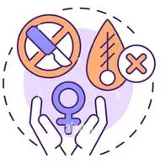
In 2024, NAFIS provided comprehensive healthcare services in Togdheer, Sool, and Saraar regions, reaching over 25,000 beneficiaries through medical treatment, health education, and FGM survivor support. Key highlights include:

2.1. Community Health Education and Capacity Building

456 individuals

In the Togdheer and Saraar regions, our mobile health teams trained on essential public health topics, enhancing community capacity to prevent diseases, support maternal health, and manage FGM-related complications.

These trainings contributed to enhanced maternal and child healthcare outcomes and improved support for women at risk of FGM-related health issues.

8,789 community members
Community members were reached with health education, resulting in improved awareness, preventive practices, and capacity to address maternal health and FGM-related complications.

Health campaigns were conducted targeting malaria, diarrhea, dengue, FGM, breastfeeding, medication adherence, antenatal and postnatal care, and chronic diseases.
2.2. Mobile Health Services and Clinical Care Provision

Sexual and Gender-Based Violence (SGBV) at hard-to-reach areas including medical, psychological, and community advocacy components.
We promoted Integrated of survivor care with broader community health services helped enhance social support networks and healing pathways.

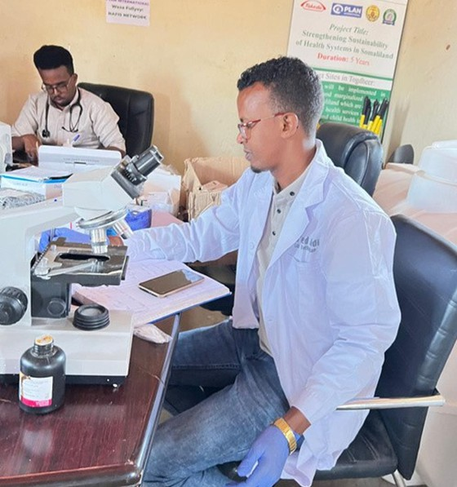
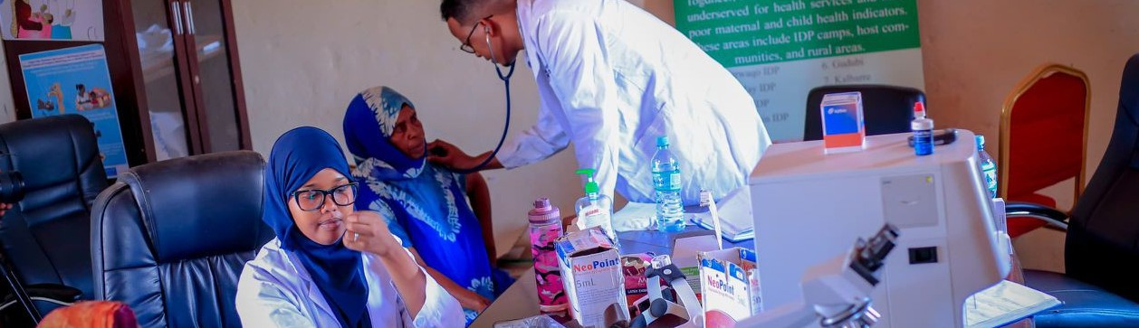
8

2.2.1. Maternal and Child Healthcare via NAFIS Mobile Clinics
Common Diagnoses Managed During Assessments

The outreach clinics conducted by mobile health teams successfully delivered maternal and child healthcare services, accompanied by effective health education and maternal care training.

The clinical assessments conducted provided detailed and thorough patient histories, capturing essential information about the patients' medical backgrounds, symptoms, and relevant lifestyle factors.

These assessments were complemented by comprehensive physical examination findings, carefully documenting vital signs, physical abnormalities, and other clinical indicators.

Additionally, diagnostic investigations were performed, which included blood test analyses revealing specific values critical to understanding the patients' health status, as well as ultrasound imaging tailored specifically for pregnant women to monitor fetal development and maternal health.
  - Anemia: Deficiency in red blood cells or
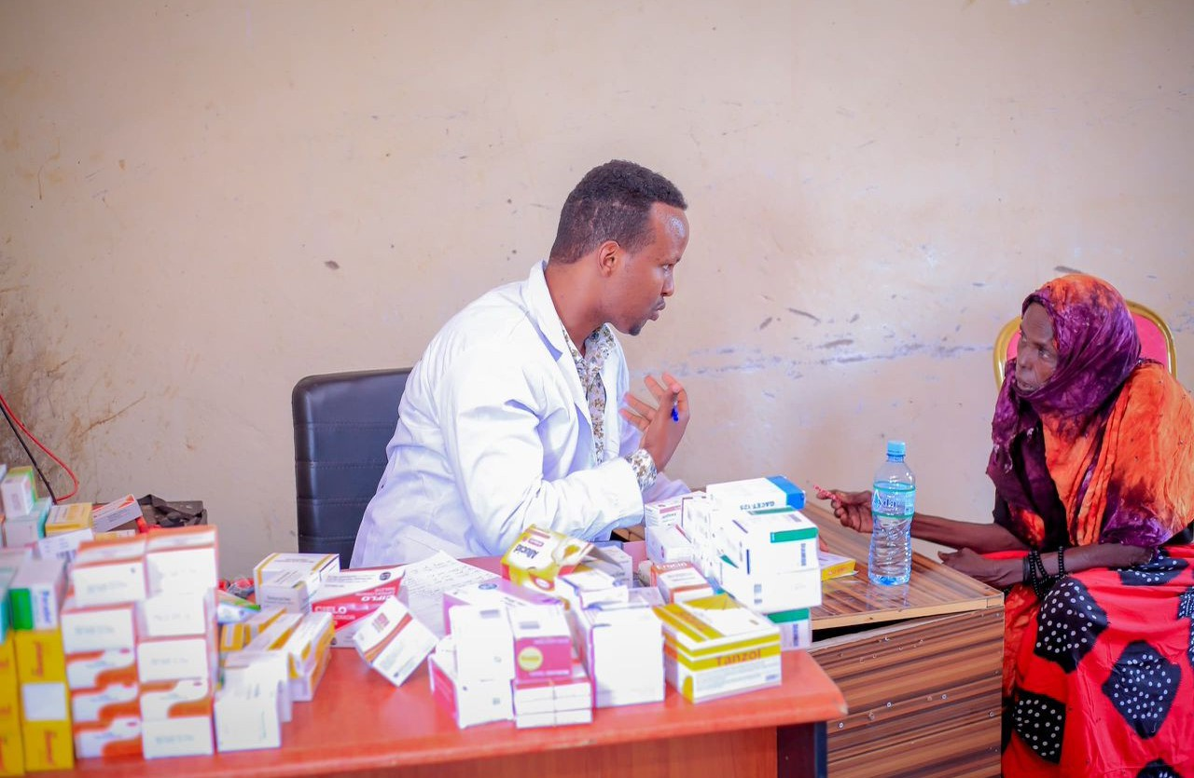
hemoglobin
  - Gastritis: Inflammation of the stomach lining
  - Urinary Tract Infections
- Pneumonia: Infection of the lungs
- Hypertension: High blood pressure
- Diabetes: Metabolic disorder affecting blood sugar levels
. Typhoid Fever: Bacterial infection
. Malaria: Parasitic disease transmitted by mosquitoes
7. Dengue Fever
. Diarrhea
9. Common Cold
Medical treatment reached 16,093 individuals, community health education benefited 9,135 people, and support was provided to 35 FGM survivors. The beneficiaries included 7,008 women and mothers, 3,854 children, 2,399 adult males, 1,638 pregnant women, as well as infants, adolescents, and newborns.

2.3. FGM Survivor Support and SGBV Services

Specialized support and capacity building were successfully provided to survivors of Female Genital Mutilation (FGM) and Sexual and Gender-Based Violence (SGBV) in hard-to-reach areas, encompassing medical assistance, psychological support, and community advocacy initiatives.

We promoted Integrated of survivor care with broader community health services helped enhance social support networks and healing pathways

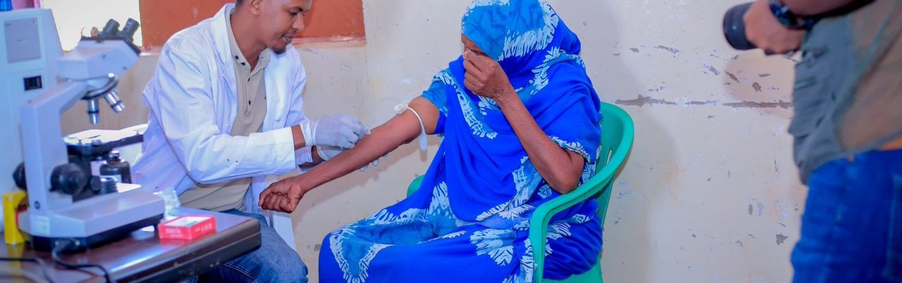
9

Protection and Prevention of Gender-Based Violence

In 2024, NAFIS strengthened protection and prevention efforts against gender-based violence (GBV) through a comprehensive survivor-centered approach, community engagement, and systemic support to ensure justice, healing, and prevention.
3.1.3. Provision of Child-Friendly Supports
3.1. VAWG Survivor Support
NAFIS provided extensive case management, medical and psychosocial support, safe spaces, and enhanced access to justice for survivors across Sool, Sanaag, Togdheer, and Maroodi-jeeh regions

3.1.1.
Case Management
Services for VAWG Survivors
NAFS NETWORK Support reached 780 survivors (772 females, 8 males), addressing cases of psychosocial abuse (286), domestic violence (132), rape (29), FGM (26), child neglect, and abuse. The services provided included
92 medical treatments, 698 psychosocial counseling sessions, 431 transportation assists, and 189 nutritional supports, significantly enhancing access to healthcare, protection, and justice mechanisms.
3.1.2. Medical and Psychosocial Support for FGM Survivors

In partnership with WAAPO, safe spaces in Burao and Hargeisa aided 324 children and 291 adults with psychosocial support, referrals, and shelter. Distributing 126 child-friendly kits in six IDP camps promoted inclusion, while child protection committees addressed over 20 abuse cases.

35 women suffering FGM complications received specialized care; 25 treated medically at Burao Regional Hospital and 9 underwent surgery. These interventions reduced physical suffering and supported emotional recovery.

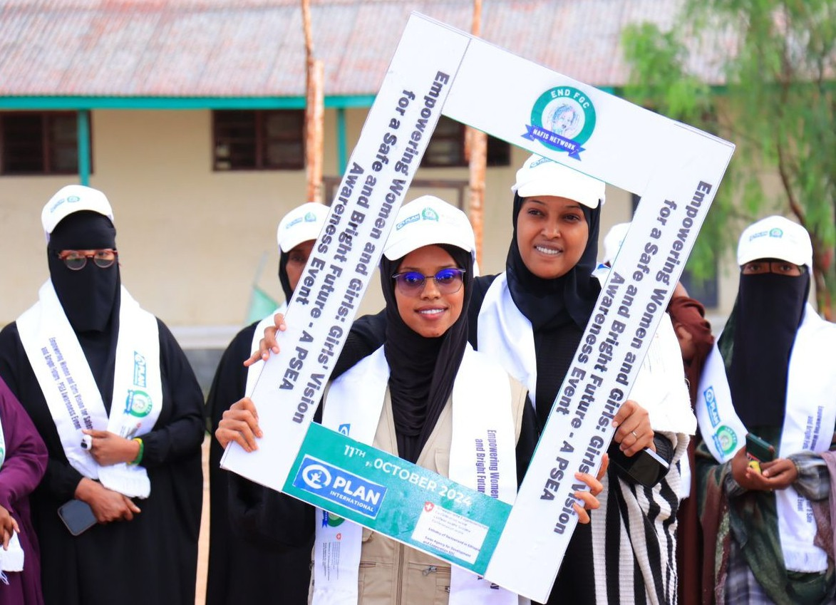
10

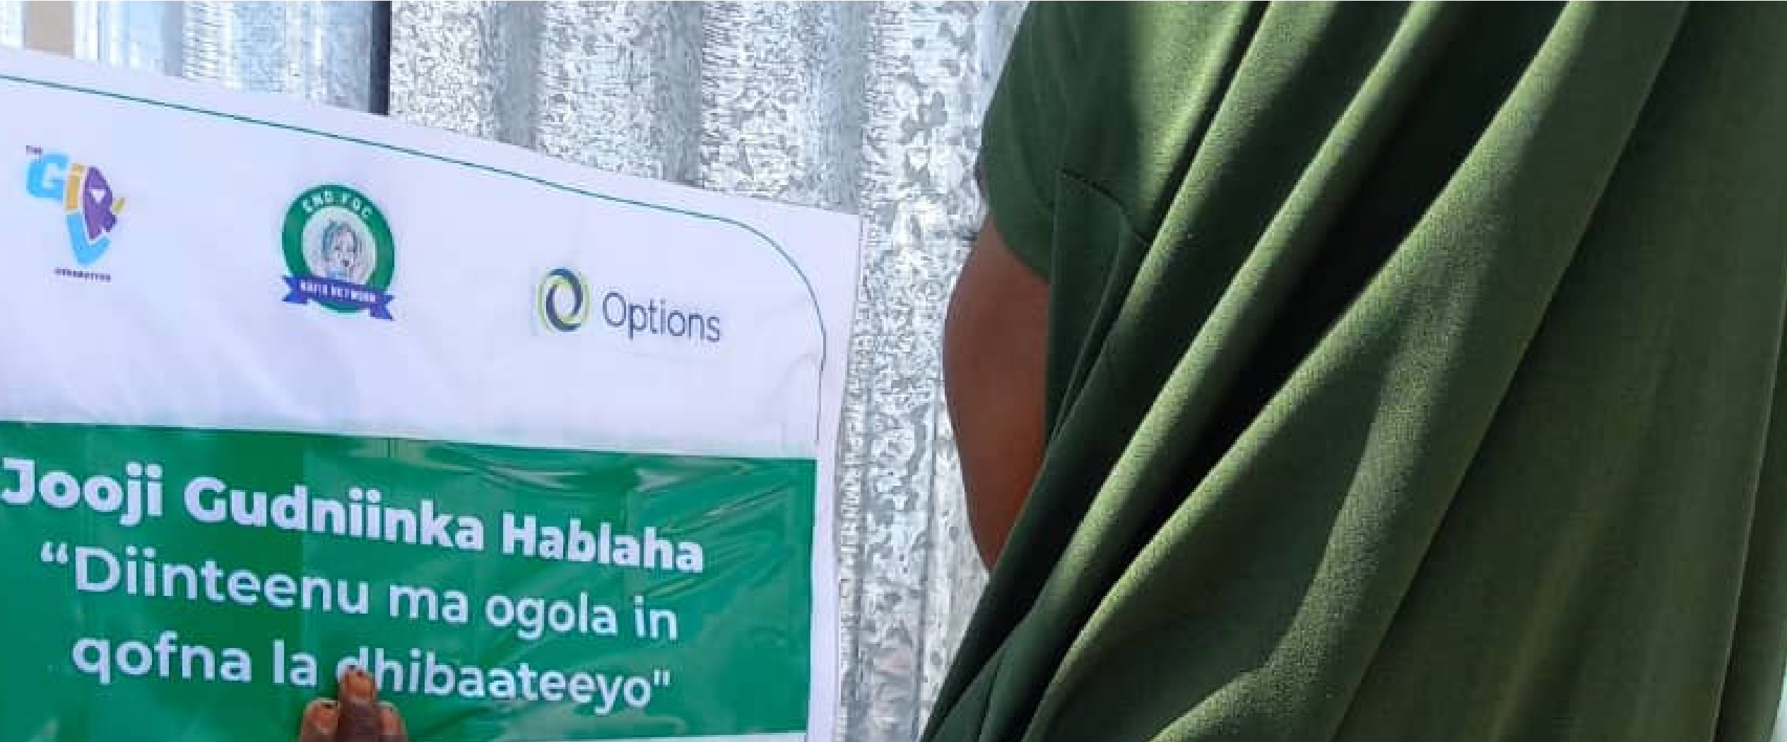
. Protection and Prevention of Gender-Based Violence

Strengthening Survivor Support Systems and Access to Justice
Referral pathways for medical, psychosocial, and legal services were strengthened through partnerships with legal aid and ADR centers. Key policy reforms included the anti-FGM policy, Gender Policy, Sexual Offences Bill, and national approval of the FGM/C policy. Community programs expanded support for safe schools and livelihood grants for former FGM practitioners.
    - SHGs and CLAs
Support for VAWG Survivors
As a result, NAFIS strengthened survivor support frameworks by integrating with Self-Help Groups (SHGs) and Cluster- Level Associations (CLAs), enabling effective community mobilization, enhanced resource sharing, and greater survivor empowerment, thereby embedding comprehensive and sustainable protection
interventions throughout Somaliland.

VAWG and FGM
Elimination
The quarterly GBV forums by NAFIS Network empowered women in SHGs to voice concerns and access support, while involving men, youth, and leaders strengthened advocacy for women’s rights and boosted participation. Additionally, distributing hygiene kits to 40 people in Xidh-Xidh village improved community well- being.

11
3.1.3. Provision of Child-Friendly Supports
615 individuals,
In partnership with WAAPO, safe spaces in Burao and Hargeisa supported 324 children and 291 adults with psychosocial aid, referrals, and shelter. Distribution of 126 child-friendly kits in six IDP camps boosted inclusion, especially for children with disabilities. Child protection committees handled over 20 abuse cases, strengthening community protection.
3.1.4. Strengthening Survivor Support Systems and Access to Justice
As the NAFIS Network, we have reinforced referral pathways to ensure coordinated medical, psychosocial, and legal services. We have expanded our partnerships with legal aid and ADR centers to improve access to justice. Our initiatives have contributed to policy reforms, resulting in the drafting and national approval

Child protection awareness initiatives successfully engaged a total of 8,470 children and adolescents.

7,185 participants, mainly girls including those with disabilities, were reached in IDP camps through programs to prevent FGM/C and early or forced marriages, followed by awareness sessions, educational materials, and community dialogues to promote change.
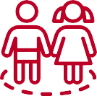
Interactive school sessions reached 1,285 students and trained teachers to detect and refer FGM-related or sexual abuse cases, improving timely intervention.
Nafis Network spearheaded the creation of five Safe Spaces within schools to offer support for girls, resulting in enhanced access to a secure and supportive environment for their well-being.

A total of 72 community volunteers and leaders were trained in child protection, case management, and referral systems, while 66 religious and traditional leaders were equipped to combat harmful practices like FGM/C and early marriage As a result, community awareness and response to child protection and harmful practices significantly improved.
3.1.7. Child Protection
25 youth social media activists were trained in behavior change communication focused on child protection.
National and regional coordination meetings strengthened child protection mechanisms and contributed to the passage of child protection legislation
3.1.8. Safety of Advocates
We build risk mitigation efforts that are implemented by strengthening justice forums and support structures including Community-Based Protection (CBP), SHGs, Case Management Committees (CMCs), and Human Rights Advocates (HRAs).

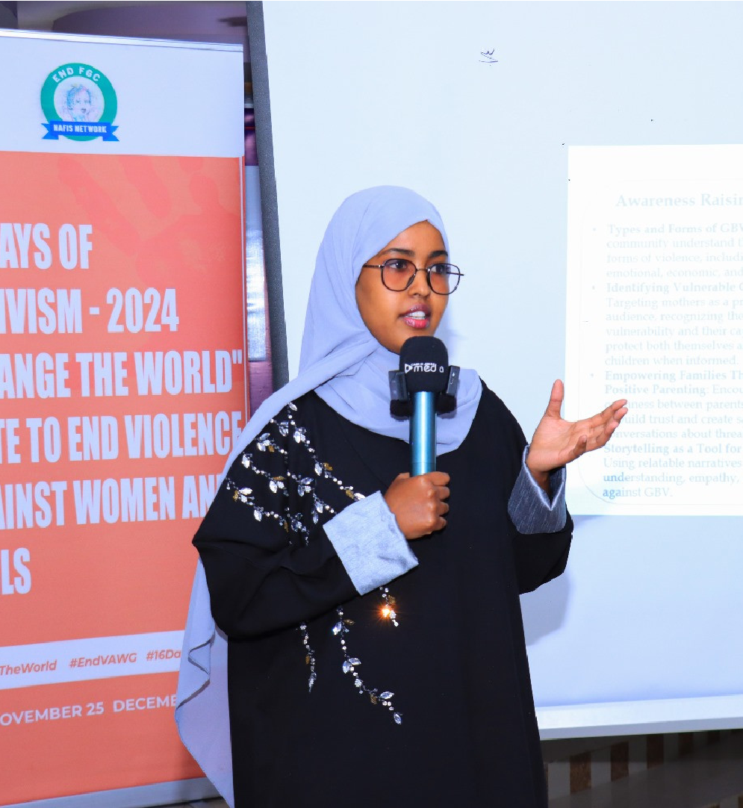
3.
Protection and Prevention of Gender-
Based Violence
NAFIS Network organized quarterly GBV discussion forums for
women in SHGs, engaging men, youth, and traditional leaders to support women's rights and boost their decision-making representation. Hygiene kits were distributed to 40 individuals in Xidh-Xidh village, including women, girls, and persons with disabilities, addressing issues related to VAWG and FGM.
As a result, Women's Rights Organizations (WROs) led grassroots advocacy efforts against violence against women and girls (VAWG), resulting in increased community awareness and strengthened support systems to combat VAWG.
12
3.1.6. VAWG and FGM Elimination

- Capacity Building and Knowledge Sharing

In 2024, NAFIS Network trained over 16,000 individuals in leadership, rights advocacy, child protection, and FGM/C prevention, resulting in empowered communities driving change. Awareness campaigns reached thousands, promoting gender-based violence prevention, health, education, and hygiene. These efforts led to increased inclusive participation, shifted harmful norms, and strengthened community resilience in Somaliland.

Strengthening Civil Society Engagement
- 15 Civil Society Organizations (CSOs) trained on advocacy, women’s rights legal frameworks, community mobilization, and survivor-centered approaches to combat VAWG.
- 200 Women’s Rights Organizations received specialized training on sensitive, confidential handling of VAWG cases.
Empowering Local Communities to Combat FGM/C

2,000 women in Togdheer were trained on leadership, community rights, and advocacy against FGM/C. Many of these women became active advocates, leading community efforts to end FGM/C
Ten female change agents underwent in-depth advocacy training and led local campaigns that resulted in 600 women publicly committing to end FGM/C and early or forced marriages in their communities.
230 individuals (216 women, 8 youth, 6 persons with disabilities) received leadership training to enhance decision-making participation; as a result, their involvement in decision-making processes increased.

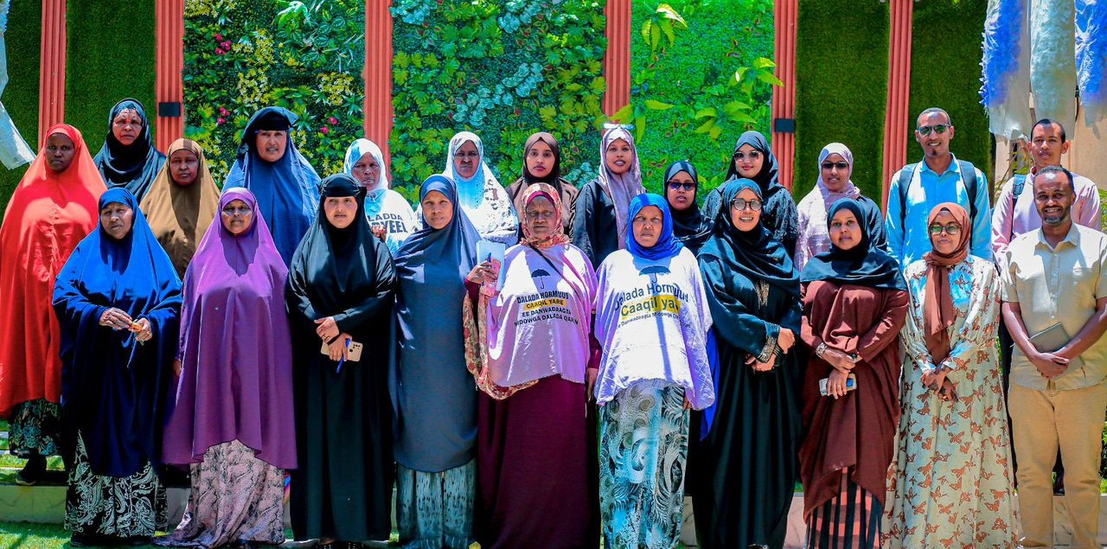
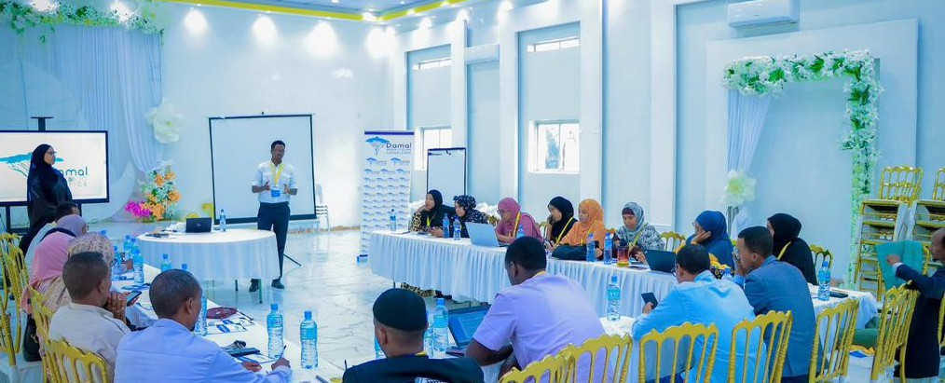
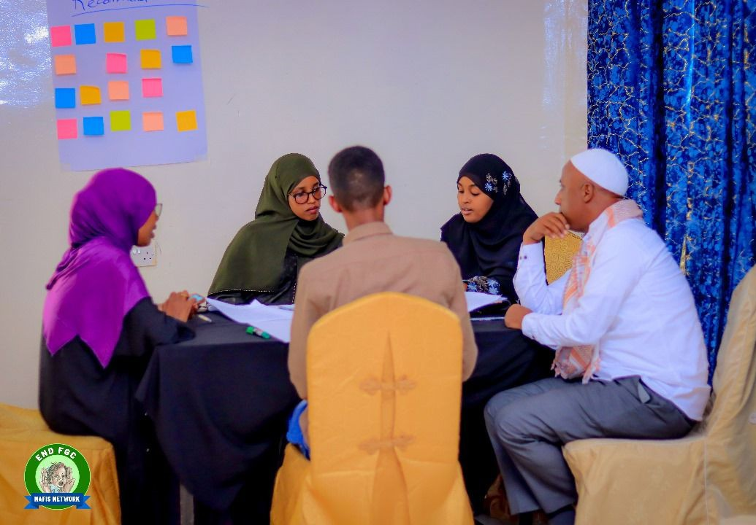
Promoting Gender Equality, Peacebuilding, and Human Rights
Ten CSOs were trained to lead peacebuilding and gender equality efforts, strengthening local leadership. Custom manuals enabled 100 SHG members to learn human rights and conflict resolution. Additionally, 26 participants received advocacy training to boost women’s leadership and participation.
13

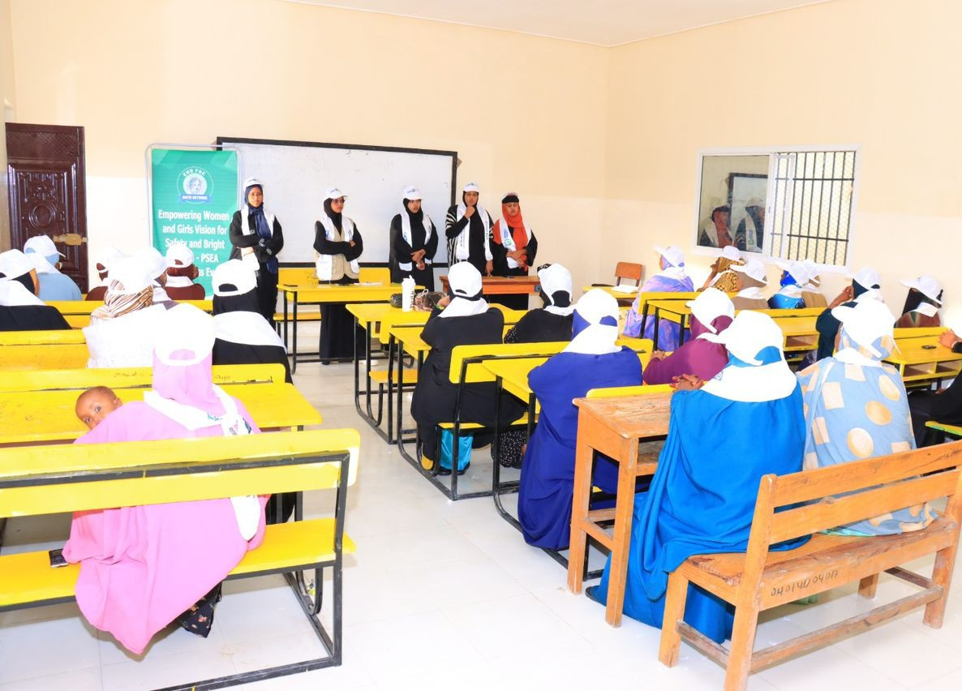


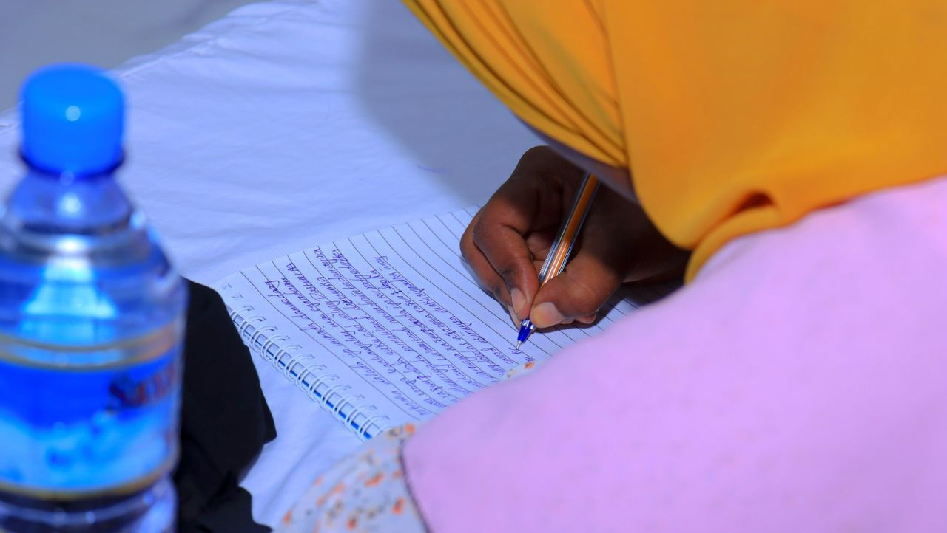
Teachers in five Maroodi-jeeh schools
were trained to deliver monthly FGM advocacy, reaching about 360 mostly
female
boosting
students
per session and
awareness
and
advocacy
against FGM.
Teachers equipped to identify, support, and refer students affected by FGM- related health issues or sexual abuse.
After establishing five Safe Spaces in schools for immediate support to girls in emergencies, the next steps are training staff to manage these spaces, raising student awareness about their availability, and
integrating emotional monitoring
counseling for ongoing
support.
Additionally,
and evaluation were
implemented to assess impact and improve effectiveness.
4. Capacity Building and Knowledge Sharing

72 community volunteers and leaders trained on child protection, case management, and referral systems.
66 religious and traditional leaders trained to address harmful cultural practices such as FGM/C and early marriage.
25 youth social media activists trained in social communication and behavior change to mobilize online support against FGM/C and for child protection.
Child Protection Training
School-Based FGM/C Advocacy

Case Study: Capacity Building and Knowledge Sharing

Community-Based Paralegals (CBPs), Self- Help Groups (SHGs), Community Management Committees (CMCs), and Human Rights Advocates (HRAs) have been strengthened and expanded to enhance grassroots access. Following these efforts, further steps can include continuous training, increased resource allocation, and community engagement initiatives to sustain and build upon these improvements.
Strengthening Justice Forums

Maria, a community health worker, attended a workshop on maternal and child health, gaining skills in prenatal care, nutrition, and immunization. She then shared this knowledge with fellow volunteers, forming a support network. Consequently, the village saw better health outcomes, including increased check-ups and vaccination rates. This demonstrates how capacity building and knowledge sharing can enhance community health services.

14

- Policy Advocacy and Lobbying

NAFIS Network's 2024 Milestones in Advancing Legal Protections for Women and Girls in Somaliland
In 2024, the NAFIS Network achieved major successes in advancing legal protections for women and girls.

The national FGM/C policy was approved by the Ministry of Employment, Social Affairs, and Family (MESAF), and the Anti- FGM Bill was included on the Somaliland parliament's agenda for the first time since the 2021 elections.

NAFIS Network also fostered strategic partnerships with government and community stakeholders, supported Alternative Dispute Resolution (ADR) Centers, and promoted community paralegals to enhance justice service delivery.

High-level dialogues with government officials increased political commitment to ending harmful practices. These efforts have significantly contributed to a safer and more equitable environment for women and girls in Somaliland.

Policy advocacy Campaign
In 2024, NAFIS Network played a pivotal role in advancing legal reforms to protect women and girls, particularly around Female Genital Mutilation/Cutting (FGM/C) and Violence Against Women and Girls (VAWG).
Engagement with Policy and Decision Makers
NAFIS network conducted regular consultations and debriefings with ministries and parliamentary committees to ensure ongoing communication and alignment. Organized a high-level dialogue with 42 key stakeholders, leading to strong commitments on legislative changes and implementation. Coordinated national and regional meetings with MESAF to enhance child protection response mechanisms.
Media and Public Engagement

We implemented awareness campaigns to promote community empowerment as part of the broader Women’s Empowerment program. These campaigns helped women become more informed and active in preventing FGM/C and VAWG by spreading crucial messages and encouraging their participation in advocacy and protective actions.

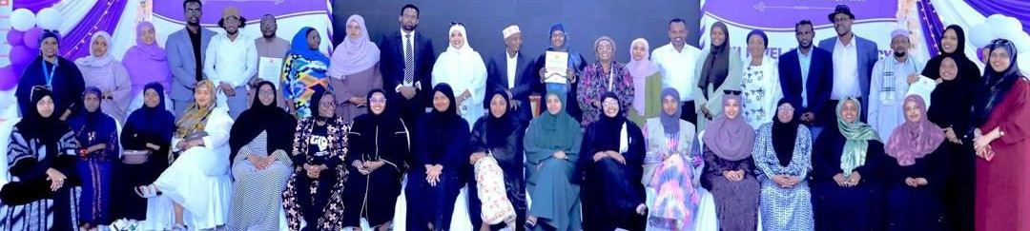
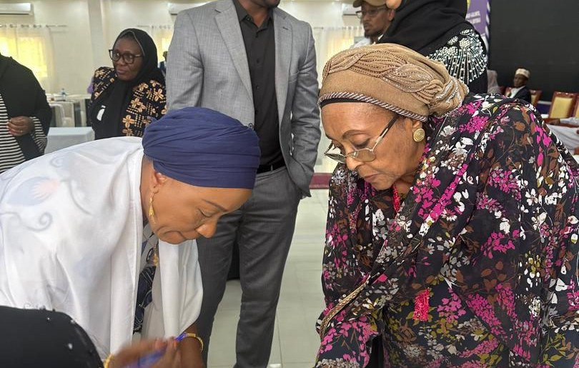
15

Community-Led Advocacy
Nafis conducted advocacy trainings for female change agents and Civil Society Organizations (CSOs). Following these trainings, the participants enhanced their skills in community rights awareness and advocacy. This improvement empowered them to lead successful community-driven initiatives that challenged and reduced harmful practices such as female genital mutilation/cutting (FGM/C) and early marriage.
What changes have been made?

Federations and Cluster Level Associations (CLAs) actively engaged in advocacy and legal empowerment led to trained women making public commitments.
As a result, community mobilization efforts
demonstrated effective
community-led advocacy models that aligned with policy goals.
The Qaran Federation in Burao conducted a comprehensive peace campaign, engaging over 120 participants to foster unity and promote non-violence. Additionally, approximately 80 members of self-help groups were actively involved in consultations aimed at improving human rights reporting and protection.
The Civil Society Organizations (CSOs) have orchestrated comprehensive collaborative initiatives to significantly enhance their advocacy efforts, leading to extensive community engagement and substantial measurable advancements in gender equality and peacebuilding initiatives.

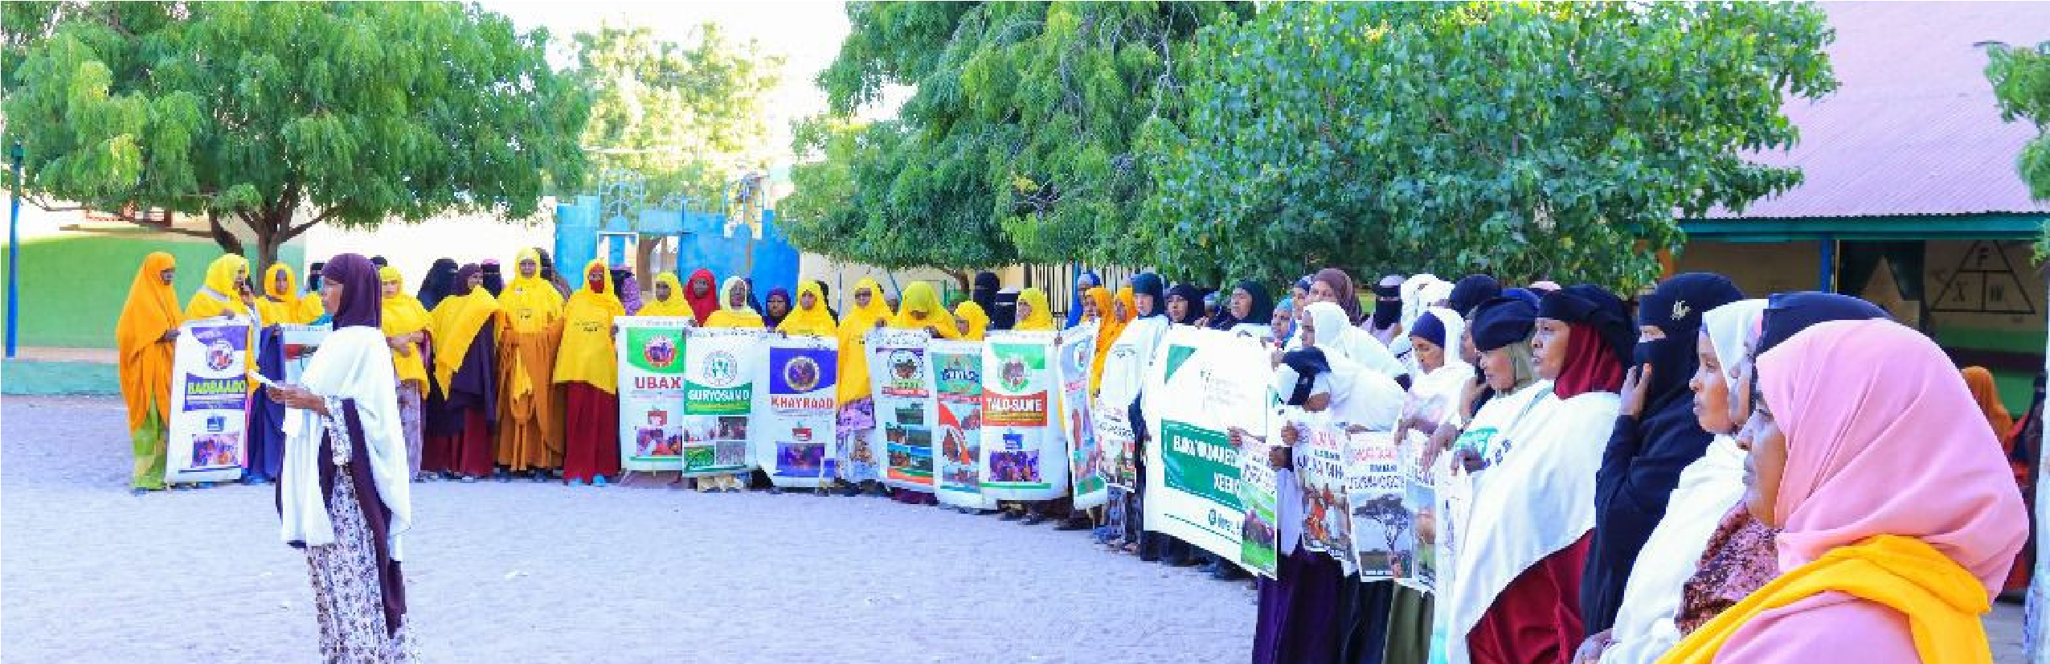

Case Study: Community-Led Advocacy for Ending FGM
In Hargeisa and Burao, Cluster Level Associations (CLAs) led a successful campaign to end Female Genital Mutilation (FGM). Through advocacy trainings, female change agents and civil society organizations (CSOs) were empowered to raise awareness and mobilize their communities. Public commitments and community gatherings were organized, culminating in a declaration by community leaders to end FGM. This grassroots movement demonstrated the power of community-led advocacy in driving social change and promoting gender equality. The efforts of CLAs and CSOs not only raised awareness but also fostered a sense of solidarity and collective action among community members, creating a more inclusive and just society

16

. Coordination and Networking


6.1. Regional Collaboration and National-Level Advocacy Platforms

As a result of our collaboration with the Ministry of
Employment, Social Affairs, and Family (MESAF) and the Child Protection Working Group, child protection and FGM/C policy enforcement were significantly strengthened.
Participated in regional conventions on FGC
policy enforcement with East African stakeholders, fostering cross-border collaboration.

Delivered training and capacity building across multiple regions including Togdheer, Saraar, and Maroodi-jeeh, demonstrating broad regional collaboration and stakeholder engagement.
6.2. Strategic Alliances

NAFIS NETWORK facilitated multi-sectoral collaboration among government ministries, civil society organizations (CSOs), Women’s Rights Organizations, and regional actors to strengthen advocacy efforts.
Collaborated with various CSOs, Women’s Rights Organizations, and community structures to enhance national advocacy platforms and strategic alliances for the NAFIS Network.

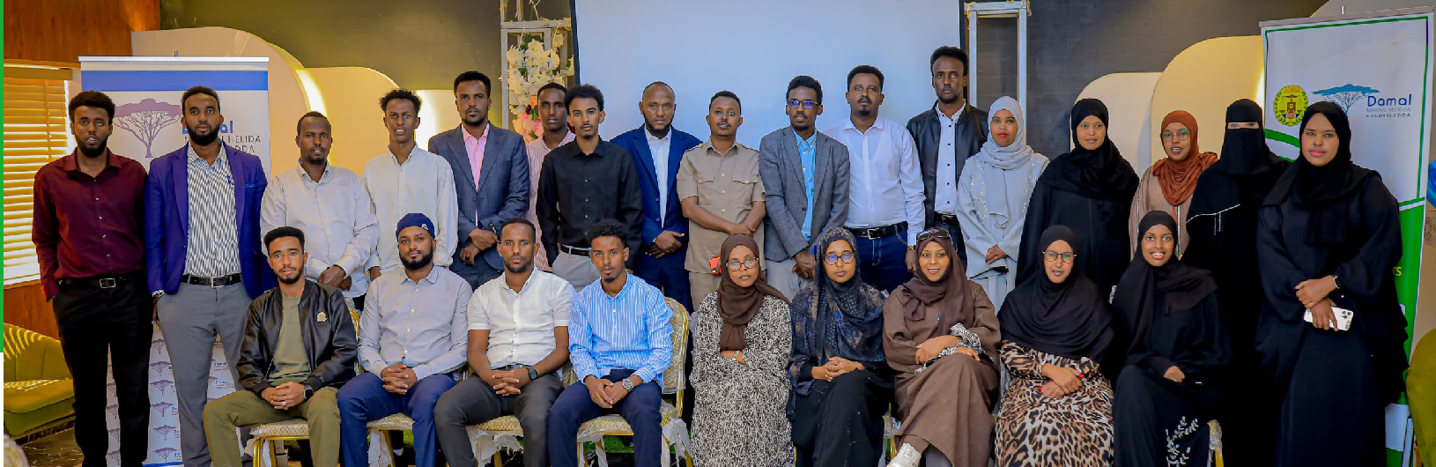
6. Coordination and Networking
17

6.3. Information Sharing Networks
The NAFIS Network expanded and strengthened community networks including Self-Help Groups, Community-Based Paralegals, Human Rights Advocates, and Community Management Committees to enhance real-time information sharing, collaboration, and learning. It also facilitated quarterly justice forums and community dialogues, promoting communication and learning around justice access and protection.
6.4. Partnerships and Networking in Survivor Support
Through collaboration with WAAPO Safe Spaces, legal aid groups, ADR centers, and government ministries, the NAFIS Network strengthened referral systems and advocacy for survivors, creating safe spaces and coordinated support to improve assistance efforts.

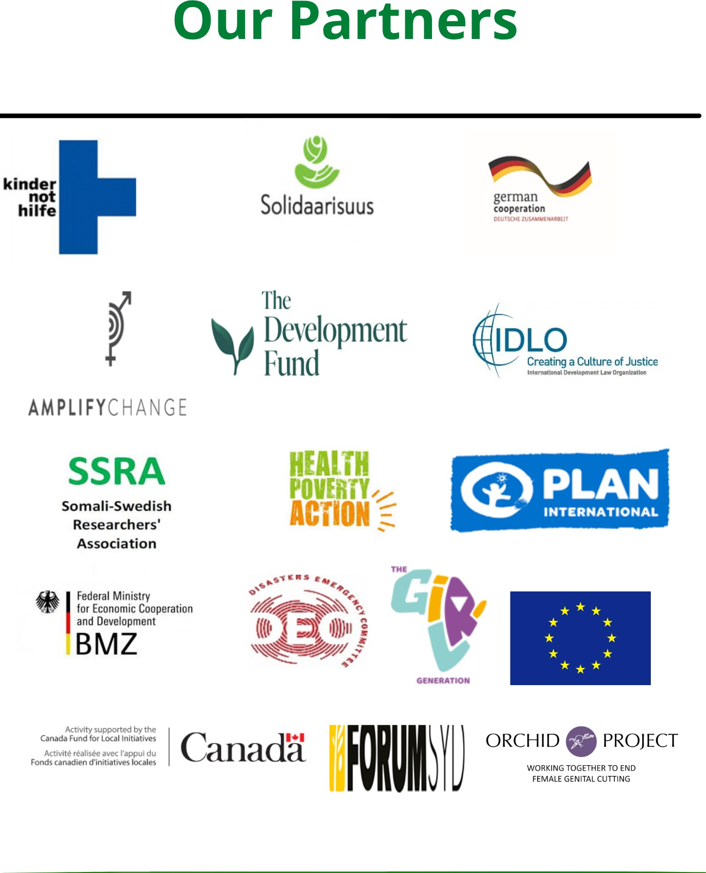

18

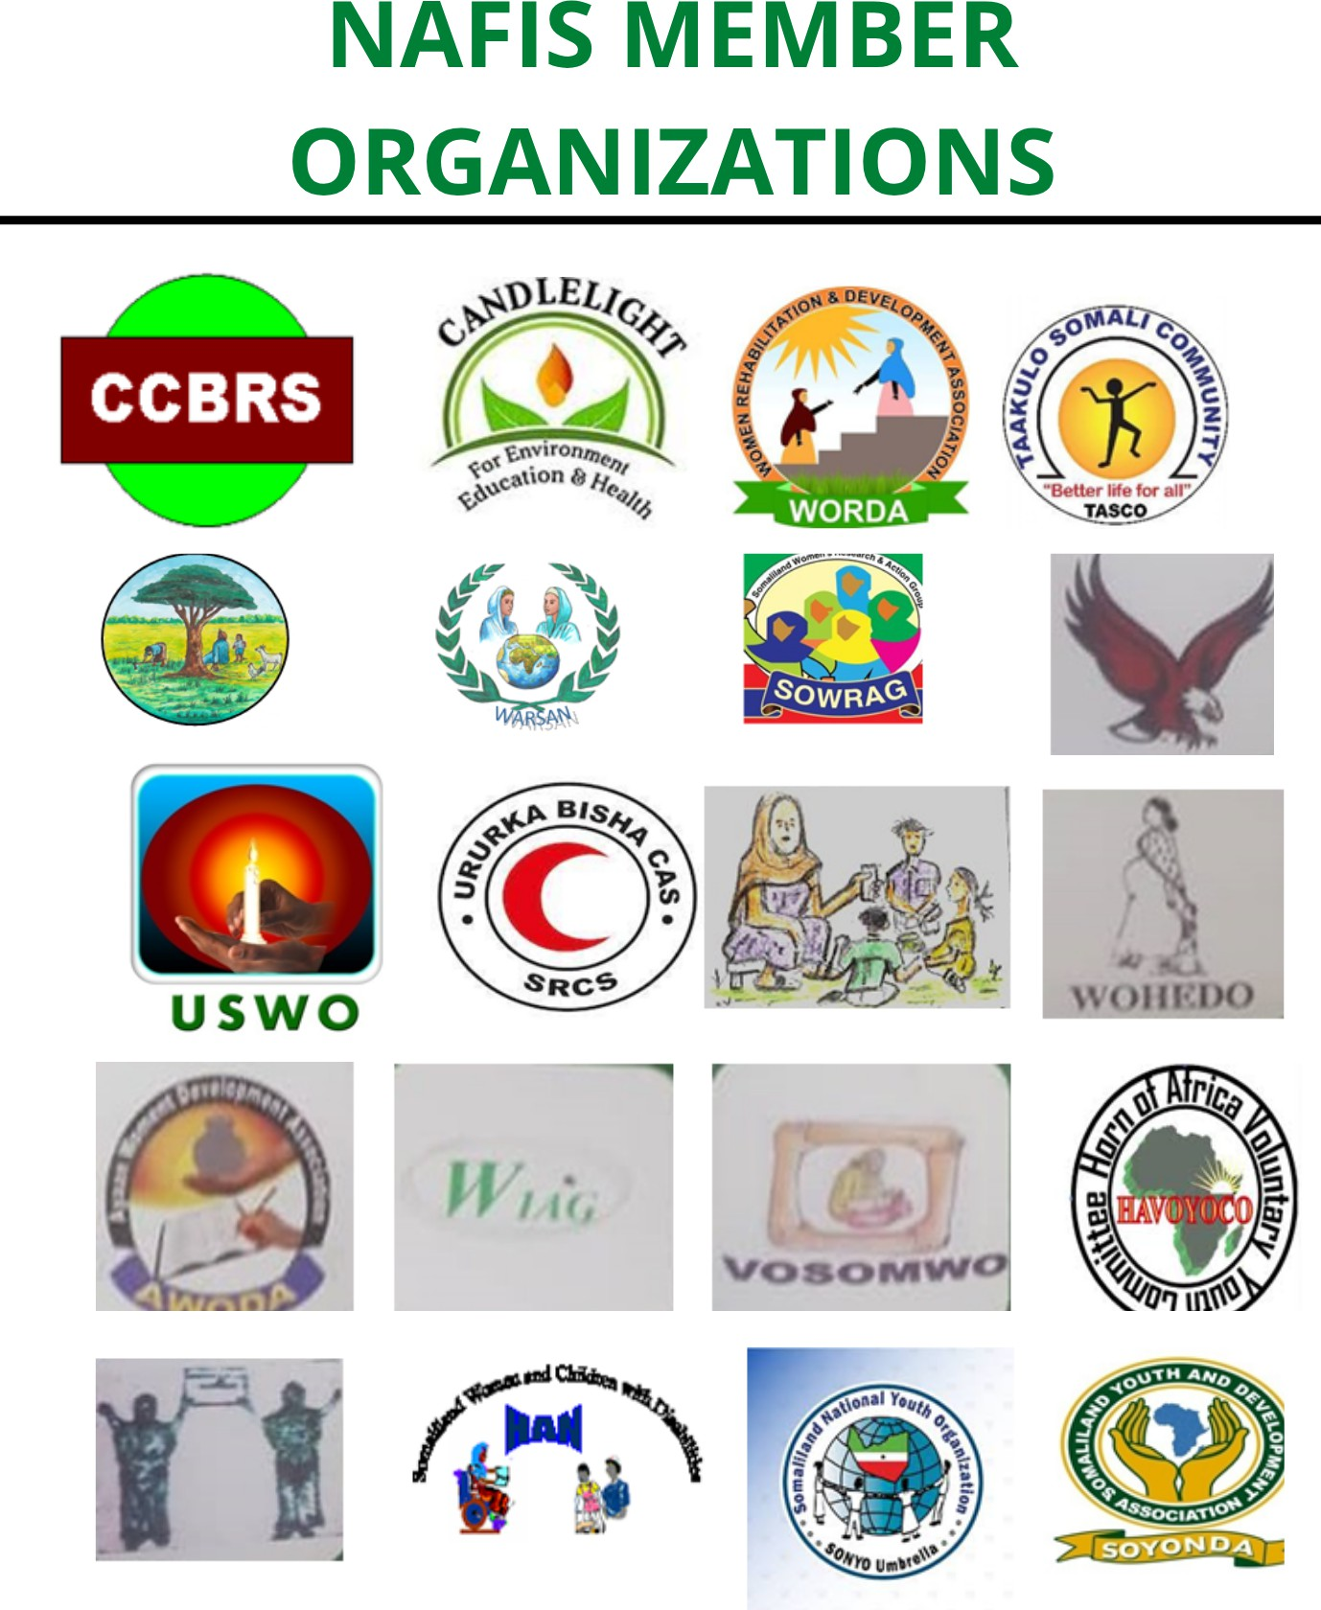

19

